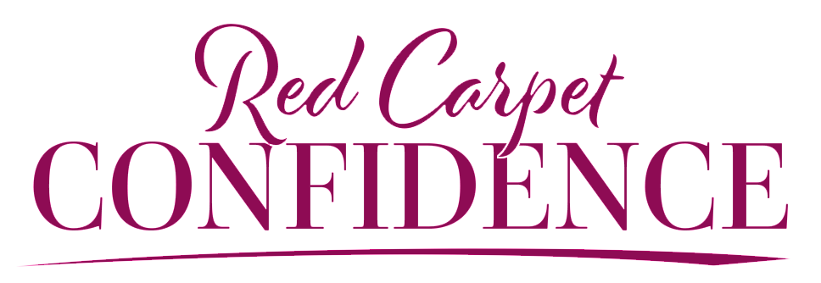

HILARY BILLINGS RIDER

We’re so excited to be teaming up with you to make your next event a memorable experience! Thank you for having us. While she may be a beauty queen and red-carpet connoisseur, Hilary is very low maintenance. However, to help us prepare for your event, we do find it helpful to review a few items.

Hilary is seasoned on the stage, having hosted, emceed and spoken in almost every imaginable environment. While she’s flexible and can easily adapt, we’ve learned that certain preparations help ensure your audience receives the maximum benefit of her message.

We appreciate your willingness to accommodate as many of these requests as possible. These considerations will help us properly prep the stage to provide an optimal and unforgettable experience for your audience.

- Hilary’s presentations use large embedded videos, custom fonts, custom layouts, custom colors, and advanced animation. Because of this, we ask that she be able to run the presentation from her personal laptop (17-inch MacBook Pro). While we appreciate your production company/AV staff wanting to run the presentation on their machines, in our experience, there’s always something in the custom design that gets lost in translation. To ensure your attendees get the premium experience they deserve, Hilary will bring all the adapters and be ready to plug in.

- Please disallow servers of any kind from serving or clearing plates during Hilary’s presentation.

- Hilary’s microphone preference is as follows: countryman, lavalier, then wireless handheld. If there are less than 50 people in the audience a microphone will not be needed.

- If you wish to record the event, please notify us in advance. Relatedly, please do not post any slides or other content that you may have received from our team for the attendees without first speaking with us.

- If you have a projector and screens, please make sure they are set off to the side(s) of the stage and not in the center of the stage so that Hilary isn’t walking through the light of the projector. And if possible, please arrange a time for her do a 30-minute walk through and sound check when none of the attendees are in the room.

- Another priority of Hilary’s is to ensure your event runs smoothly. If you get behind schedule and you need her to cut part of her speech to make up time, she can be flexible to your needs. Regardless of whether you want her to do a truncated or full version of her talk, it helps tremendously if you can have a large clock that is easily viewable from the stage to help her adjust accordingly.

- Clients often ask if Hilary would be available for a “meet and greet” with attendees to take pictures and answer questions. Hilary is happy to do so and loves meeting attendees. We ask that this be scheduled for shortly after her presentation. We do have a separate fee schedule for other appearances (which we can talk through if you have other events surrounding her visit that you’d like her to attend). Any social outings you wish to invite her to, such as executive dinners, would not have a fee. Her intense schedule may not always permit her to accept these invitations, as being fully prepared and rested for your attendees is her top priority, and she appreciates your understanding.

- If and when booking Hilary’s hotel reservation, please reserve a non-smoking, king or queen bed, that is guaranteed for late arrival. Sometimes, due to uncontrollable flight delays, she may arrive very late at night.

- Lastly, Hilary is there to serve you and your audience. Please do not feel any need to provide an additional gift to her of any kind. (Unless it’s a puppy. Puppies are always welcome).

We’re so grateful to have the opportunity to speak to your audience and assist you in creating a memorable experience. Please let us know what else we can do to support your vision, or if you have any additional questions.

All the best,

The Hilary Billings Team

