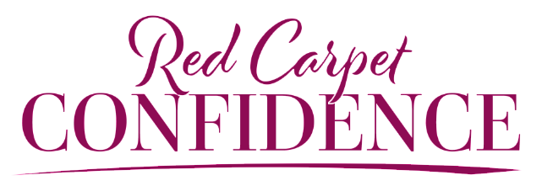

HILARY BILLINGS CUSTOMIZATION QUESTIONNAIRE

Thank you for having Hilary speak as part of your conference! Providing an entertaining, informative, and empowering experience for your attendees is our highest priority. The more information we have about your organization’s culture and goals, the more customized and connected Hilary’s content will be to your audience. Thank you in advance for filling out this questionnaire so we may provide the highest-level of performance possible.

- What is the official name of your group?

- What is the best website(s) to review for us to understand how you’ve positioned yourselves publicly?

- What is the primary purpose for having this conference/meeting?

- Please describe who will be in the audience, with as much detail as possible. We welcome any and all demographic/psychographic information.

- What do your attendees do on a daily basis?

- What terms, titles, or jargon do you use when referring to/interacting with the audience?

- What are the primary challenges they struggle with day in and day out?
- What are some of the key terms or lingo that you use on a regular basis?

- Can you please list out all acronyms that you use that your audience would recognize?

- How many people are you expecting to be in Hilary’s session?

- What will the speaking area setup be? Please describe.

- Who else will be speaking at the event? Can you please send us an agenda to review?

- Will there be VIPs in the audience that Hilary should make a point to meet?

- Have there been any speakers from past events that your audience really loved? What was it about them that worked well?

- Have you had any speakers from past events that your audience didn’t enjoy? What was it about them that did not work well?

- Who should we communicate with as our primary contact while we’re on site?

- How did you originally find out about Hilary?

