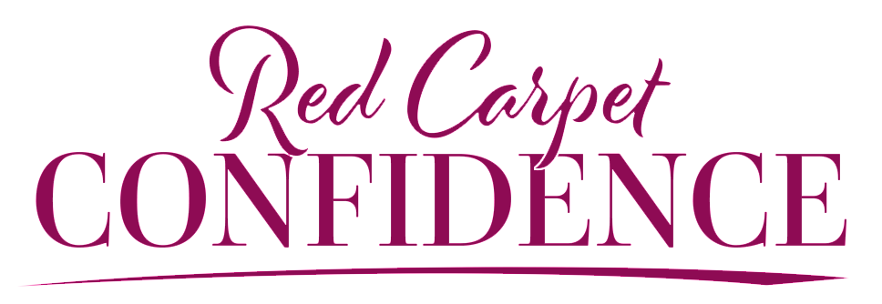

HILARY BILLINGS BIO
Hilary Billings is an on-camera host, celebrity interviewer, online influencer and host of the podcast Red Carpet Confidence. As a former Miss Nevada United States, producer for E! News and travel host for Norwegian Cruise Line, Hilary has been a featured contributor for USA Today, Thrive Global and Huffington Post as well as being featured on Extra! Entertainment TV. As a burn survivor with humorous monologue viral videos and an online audience of millions, Hilary is focused on everything but the superficial. She is a sought-after speaker and coach that helps people overcome inadequacy through finding, interpreting and affirming their self-worth.

